Incubator controller with Bluetooth

What is it?
This is digital incubator controller module with Bluetooth and dedicated Android application. It has the following features:
      - Temperature regulation using one of three methods: on/off control, proportional-integral (PI) control by heater power variation and hybrid control.
      - Humidity regulation using simple on/off control.
      - Timer for automatic rotation of eggs.
      - The heater is driven by a phase-controlled dimmer.
      - Automatic PI controller tuning implemented in an Android application.
      - Buzzer controlled by configurable protection limits for temperature and humidity.
      - Three configurable 120V TRIAC outputs, which are galvanically isolated from control side.
      - Modbus protocol over Bluetooth, i.e. device can be integrated into the larger automation system.

Device specification:
Parameter | Value
Control power supply voltage | 5V-20V
Control power consumption | 60mA at 5V input
Commutated AC mains | 120V 60Hz
Output power per channel | 100W (300W with heat sink)
Temperature range | 5 °C … 60 °C
Humidity range | 20 % … 80 %
Temperature resolution | 0.01 °C
Temperature accuracy | ± 0.3 °C
Humidity resolution | 0.04 %
Humidity accuracy | ± 2 °%

Notes:
- Temperature and humidity ranges are defined by measurements accuracy, for more information check the HTU21D data sheet.
- Control power should be provided externally, see the wiring diagram below.

Device internals:
 | Part number
Temperature sensor | HTU21D
Microcontroller | STM32F030K6T6
TRIAC | BTA08-600CWRG
Bluetooth module | HC-05

Board connections:
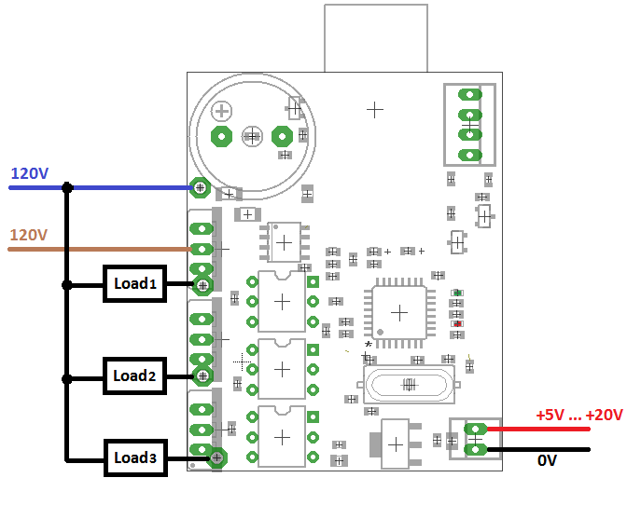
There are no fuses on board, it is recommended to place at least one common fuse before the device.

LEDs:
- Green: power on, also toggling every time during temperature measurements and Bluetooth request.
- Red: fault indication (on in case when temperature sensor fault occurred at least once).

Install of Android application

To install the application:
- Download Incubator Application.apk and copy it to your smartphone.
https://github.com/akpc806a/Bluetooth_incubator/raw/master/Mobile/IncubatorApplication.apk
- Go to menu > Settings > Security > and check Unknown Sources to allow your phone to install apps from sources other than the Google Play Store.
- Tap IncubatorApplication.apk file in File Manager. Then hit Install.
- Allow access for the application to Bluetooth network and paired devices.

First launch of application:
- Turn on the incubator controller. Make sure that green LED is blinking.
- Open phone Settings menu.
- Under "Wireless & networks," tap Bluetooth.
- Make sure Bluetooth is turned on.
- Your device will scan for and display all available Bluetooth devices in the range under "Available devices." If your Bluetooth device isn't showing in the list, tap more and then Refresh.
- Tap the HC-05 in the list of the Bluetooth devices. This is Bluetooth name of incubator controller.
- Follow the on-screen steps. If the pairing is successful, your phone or tablet connects to the device.
- If you're asked to enter a passcode - use 1234. 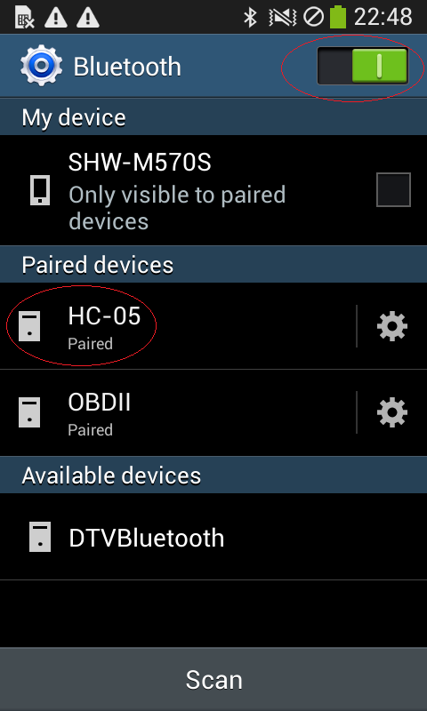
- Run IncubatorApplication application.

Android application short user guide

Connection page
Tap drop-down list and select HC-05 as Bluetooth device. It will start the connection to hardware.
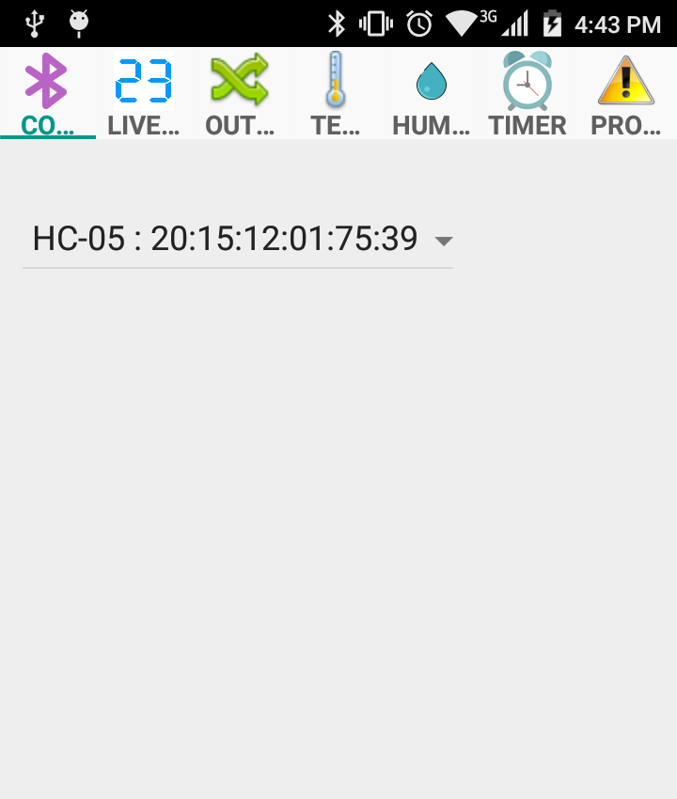

Always turn on the Bluetooth in your phone before launching the incubator application.
If you forgot to turn on the Bluetooth, turn it on and then restart the application.

Live data page
This page displays the actual temperature, humidity value and timer clock. The right column is the states of corresponding outputs: for temperature, this is the power of the heater from 0 to 100 (%), for humidity and timer it is On or Off.

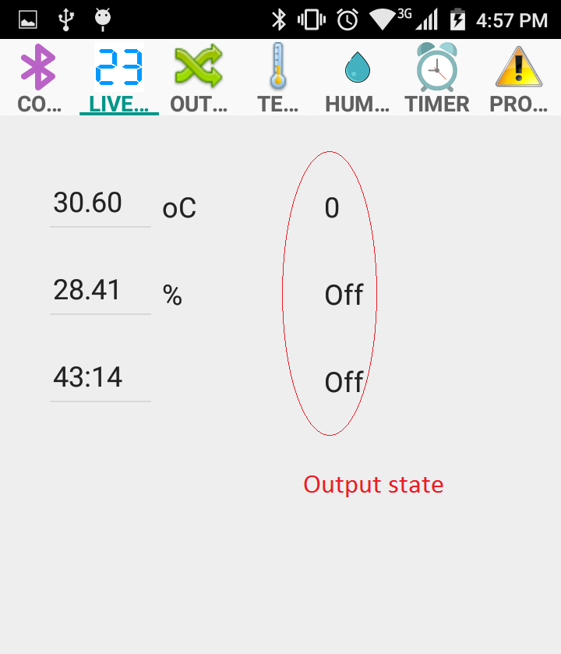

Output routing page
The device has 3 independent outputs: Output 1, Output 2, and Output 3. Each output can be driven from temperature controller, humidity controller or timer. It is also possible to assign several outputs to the same source (for example temperature controller) to provide the system redundancy.
Tap the drop-down list to select the source for corresponding output.

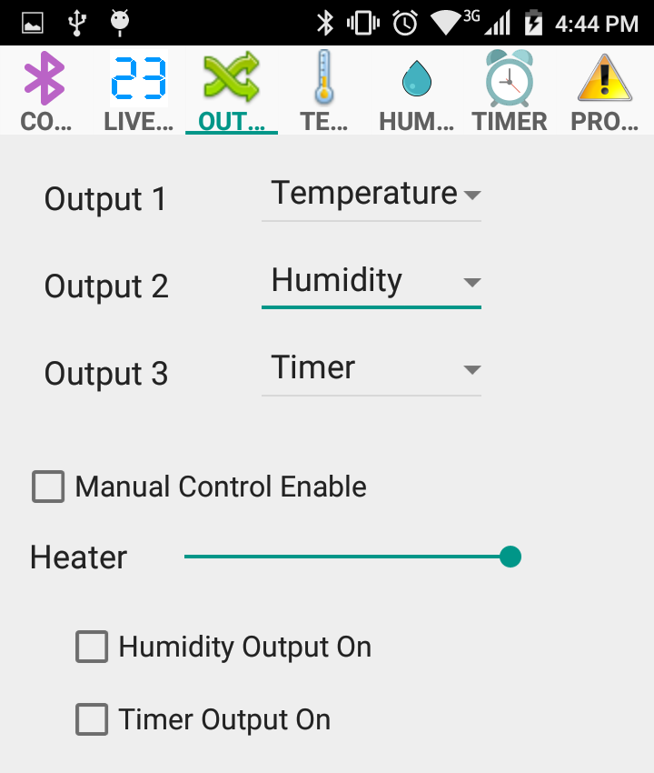

The manual mode is for testing purpose and useful to check whether a heating element or light bulb is operational as well as eggs rotation device and humidity actuator.
Tap "Manual Control Enable" to activate the manual mode. Use "Heater" slider to regulate the heater output power. Tap "Humidity Output On" to turn on the outputs assigned to humidity controller. Tap "Timer Output On" to turn on the outputs assigned to timer controller.

Temperature page
Three types of temperature controllers are implemented:
- On/Off control. The heater will be turned off if the temperature becomes higher than "Setpoint" value plus "On-Off Hysteresis" value. The heater will be turned on if the temperature becomes lower than "Setpoint" value minus "On-Off Hysteresis" value.
- PI control. This is advanced feedback control method that smoothly regulates the heater output power to match the specified Setpoint temperature.
- Hybrid method. The hybrid method combines the best properties of On/Off and PI controls: the fastest response of On/Off controller and smooth adjustment of heater power near the temperature setpoint. If the temperature is near the setpoint with tolerance defined by hysteresis value, then the PI controller is applied. If the temperature is outside the hysteresis tolerance, then On/Off controller will be applied for several cycles. After this, the initial conditions for PI controller will be calculated and PI controller will be activated.

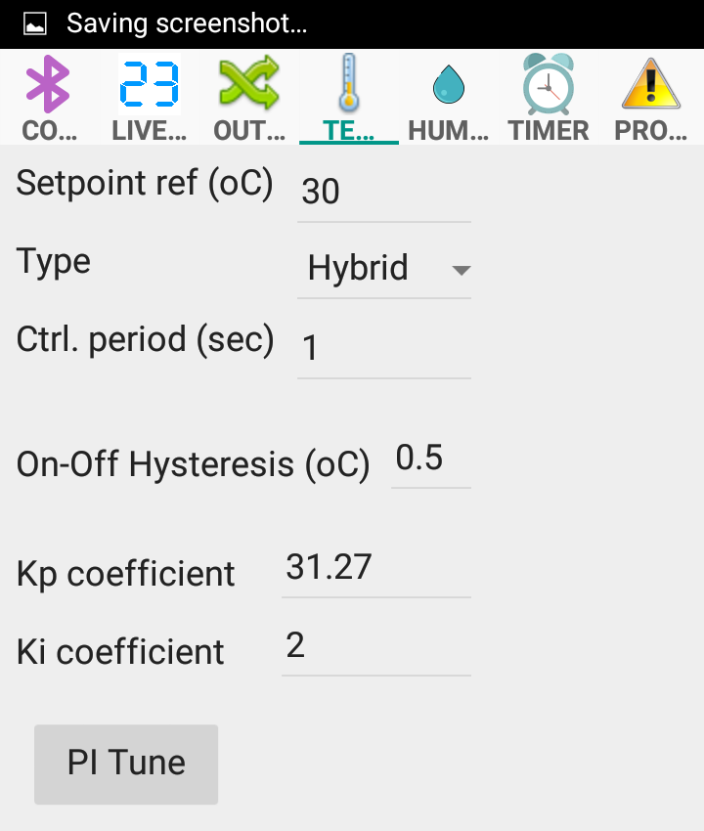

Here is a comparison of temperature responses of different regulator types for 30 °C setpoint:
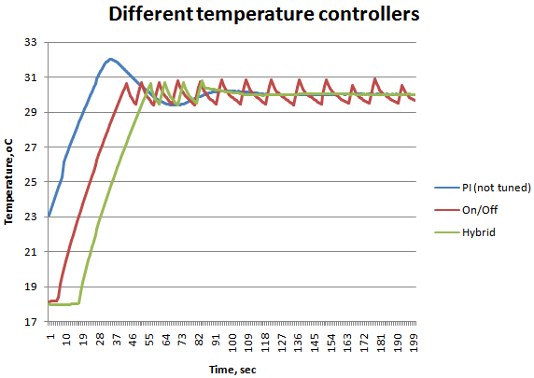
(Please note, that PI controller was not tuned in this particular test)

The "Ctrl. period" parameter determines how often temperature being read and control procedure applied. Minimal value is 0.1 seconds, values around or over 1 second are for typical incubators. You can get better On/Off control results with shorter control period.

For optimal performance of PI controller, it is necessary to perform its tuning for actual incubation camera and heater to determine Kp and Ki coefficients. The automatic tuning of PI controller is implemented in the Android application. To perform tuning follow the procedure:
- Please make sure that there are no eggs or other vulnerable materials inside the incubator (heater will be fully powered on during procedure).
- It is recommended to write previous values of Kp and Ki coefficients.
- To tune tap "PI Tune". The button will change to "Stop". The heater will be turned on.
- Monitor the temperature on the Live data page.
- If the incubator camera fully heated up and there is no considerable temperature change during a long time, tap "Stop". Usually, it will require from 20 to 40 minutes, depending on the size of incubator and heater.
- It is not recommended to allow temperature rise over 50 °C for a long time because it could damage the plastic parts in the incubator. Please monitor temperature carefully and get ready to stop tuning.

Here is the comparison of not tuned and automatically tuned PI controller:
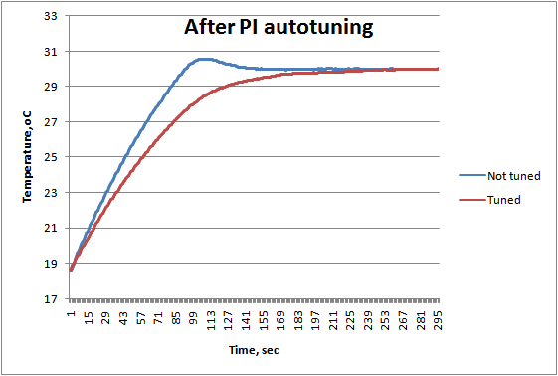

Humidity page
Humidity output will be turned off if the humidity value becomes higher than the set "Upper value". The output will be turned on if the humidity value becomes lower than the set "Lower value".
The "Ctrl. period" determines how often temperature being read and control procedure applied.
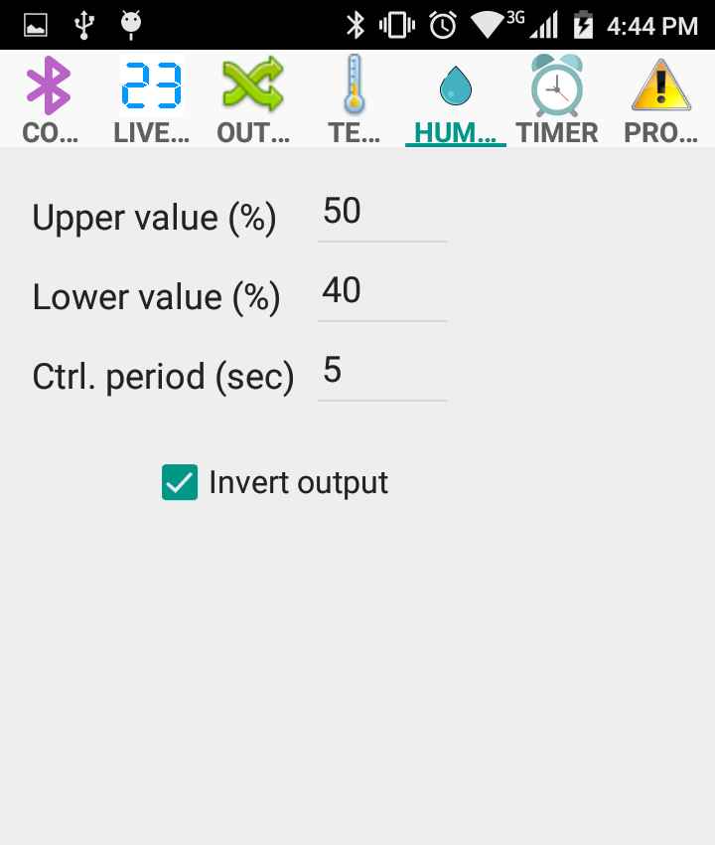
It is possible to invert the output because usually when humidity reaches the defined value the valve or actuator should be open to allow airflow into incubation camera.

Timer page

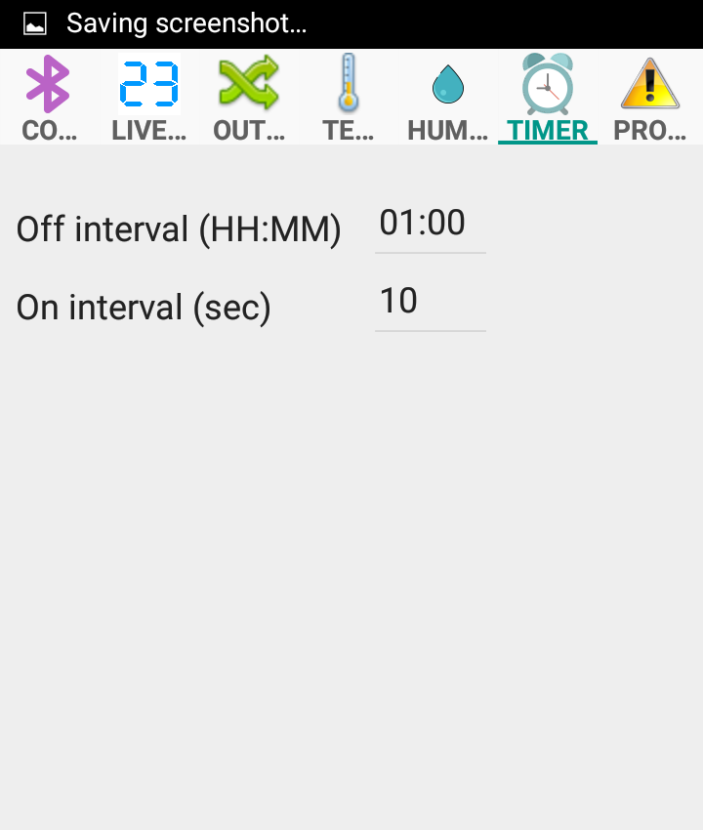

The timer for automatic rotation of eggs is controlled by two parameters: "Off interval" and "On interval". Here is timer diagram:
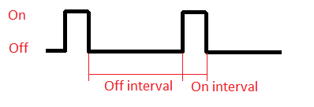

Protection page
The protection page displays configurable parameters for indication of system failure.
If the temperature or humidity will cross the corresponding defined boundary values for a specified time, the alarm will sound. To turn off the alarm one should power cycle the controller.
